Since static methods cannot be overridden so if we ever write static methods inside any interface we must also provide the body of that method

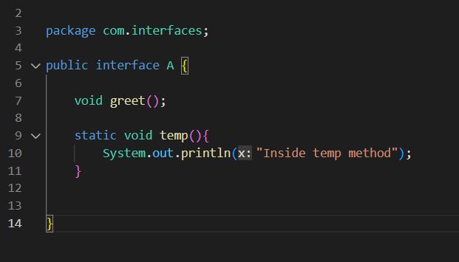

Just like with classes here also the static method is accessed by using the Interface name directly

